Viruses and plant species identity alters behavior of predators and prey in an aphid-legume system

Abstract

Herbivorous insects have dramatic impacts in crop systems as vectors of plant pathogens. Recent work has demonstrated that herbivore behavior can be altered by the presence of viruses in host plants or even in the digestive system of the insect itself. It has been hypothesized that viruses may manipulate their hosts to increase likelihood of spreading pathogens, but it is unclear if changes to aphid behavior increase or decrease susceptibility of aphids to natural enemies. In a closely-monitored greenhouse experiment, we took minute-by-minute observations of aphid behavior and compared differences between uninfected and infected plant-herbivore systems. We found that the strength of ladybird beetle effects was determined by host plant species, with strongest effects seen on a cover crop compared to two food crops. These plant species identify effects on predator-prey interactions were further modified by PEMV. The presence of virus decreased ladybird beetle recruitment to plants as measured by foraging time, and this led to lower rates of predation and decreased dispersal of aphids away from focal plants. Through these behavioral experiments, we show there is an underappreciated plant-mediated benefit that aphids gain by harboring virus or feeding on infective plants. Consequently, we predict that in this system and others, biological control of insect herbivorous may be weakened in systems experiencing viral outbreaks.

Introduction

*Big picture that needs to be set up in introduction*: aphid-vectored viruses change aphid behavior, leading to different patterns of host-plant use and change in predation risk

*Basic information:* Pea aphids are an economically important damaging pest of legume crops worldwide (citations). While feeding on plant phloem, aphids can transmit carried pathogens to plants (citations). One of the costliest impacts is transmission of pathogens, which can far outweigh the damage caused by herbivory itself (citations). Viruses can also alter plant defensive chemistry and nutritional quality, leading to indirect benefits to the vector, further exacerbating the intensity of aphid outbreaks (citations). Viruses are also increasingly appreciated for their ability to alter aphid behavior in addition to plant response to herbivores, the the ecological consequences of these behavioral changes are still poorly understood.

Methods

*Study system details*

This experiment used Pea aphids collected from Palouse agroecosystems (Eastern WA and Idaho, USA). Aphids were reared in greenhouse conditions on broad bean (*Vicia faba*), a universal host of Pea aphid populations.

The virus of interest is the RNA virus PEMV (pea enation mosaic virus) which infects cultivated legumes, including lentil, vetch, clover and dry pea (citations).

We used the convergent ladybeetle as our focal predator species. (Citations on its importance as a natural enemy and biological control agent in the field)

*Timing of plantings*

We ran two trials of the experiment. In trial 1, Seeds were sown into X size pots on Y dates. In trial 2, seeds were sown into the same pots on Y dates. We planted pea, fava, lentil, and vetch.

*Setup of experiment*

We ran a 2x3 factorial experiment, with PEMV presence absence and three plant species

The five plant species were arranged in a cross pattern (See Figure S1)

Plants were infected before the experiment (only fava)

Fava was added to arena with pea, lentil, vetch and clover already arranged in a glass terrarium

Glass terrarium already had warmed up ladybird beetles waiting to eat.

*Statistical analyses*

Results

Discussion

References

Figures

Figure 1. Ladybird beetles spent significantly more time foraging on vetch compared to Pea and Lentil.

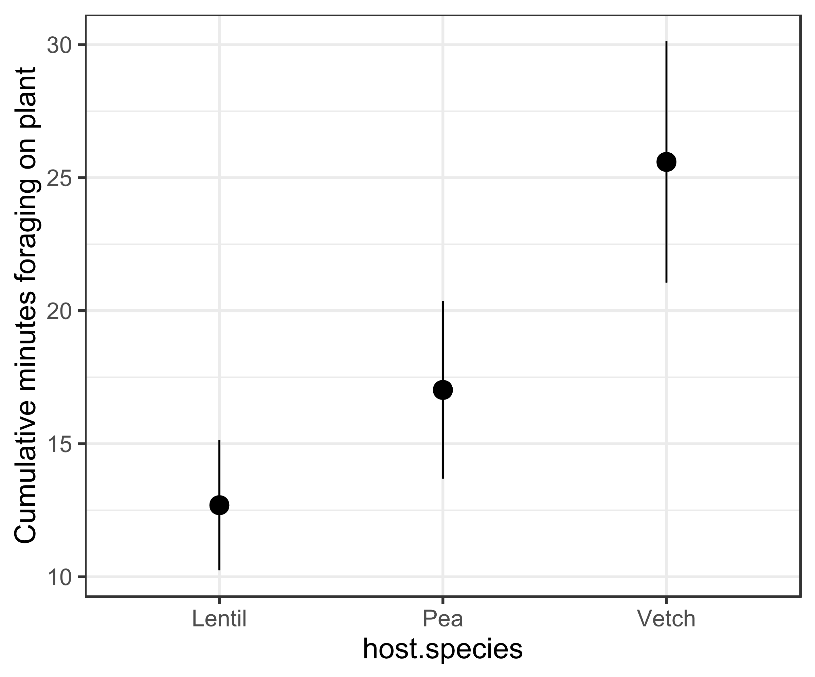

Figure 2. Total number of aphids removed from focal plant by predation or due to threat of predation. The strongest predator effects were observed on Vetch, but the strength of predatory effects were weaker in the presence of virus.

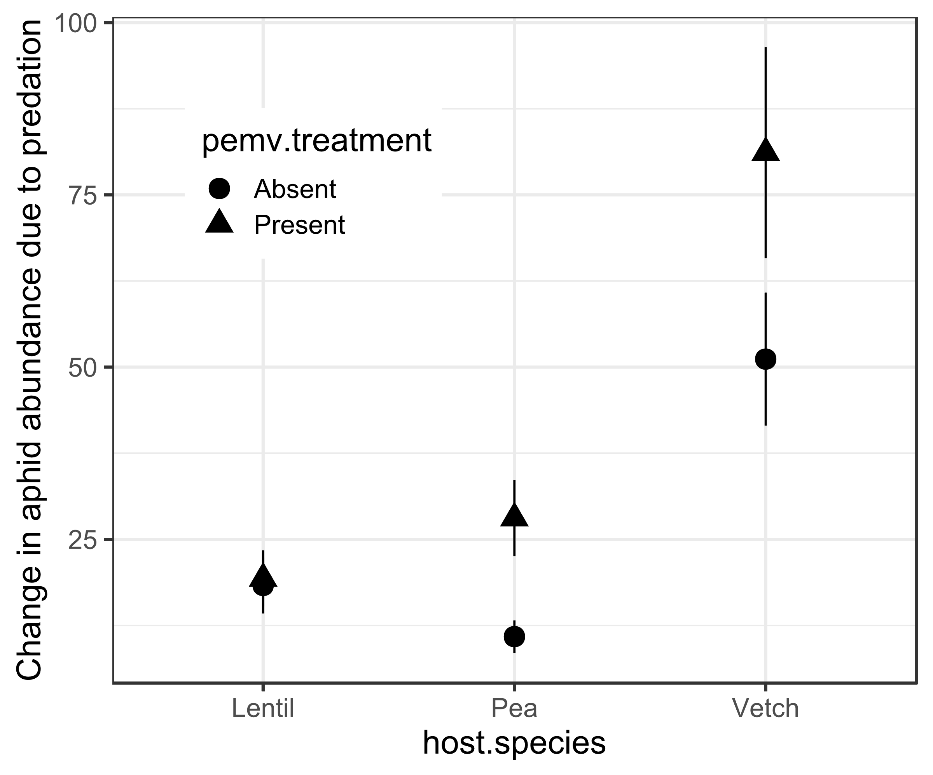

Fig 3. Aphids on infected plants experience fewer attacks from ladybird beetles.

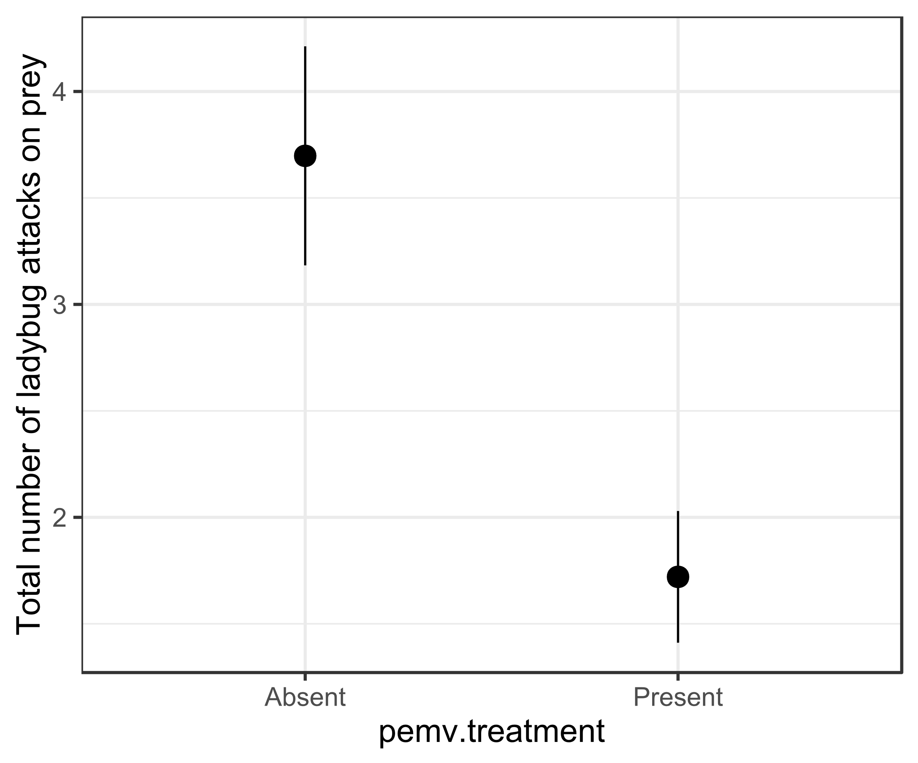

Fig 4. Aphid dispersal to new hosts was highest on vetch, but this effect was attenuated by viral presence, reducing likelihood of dispersal in response to predation to be equal to that of the lowest rate plant (Lentil)

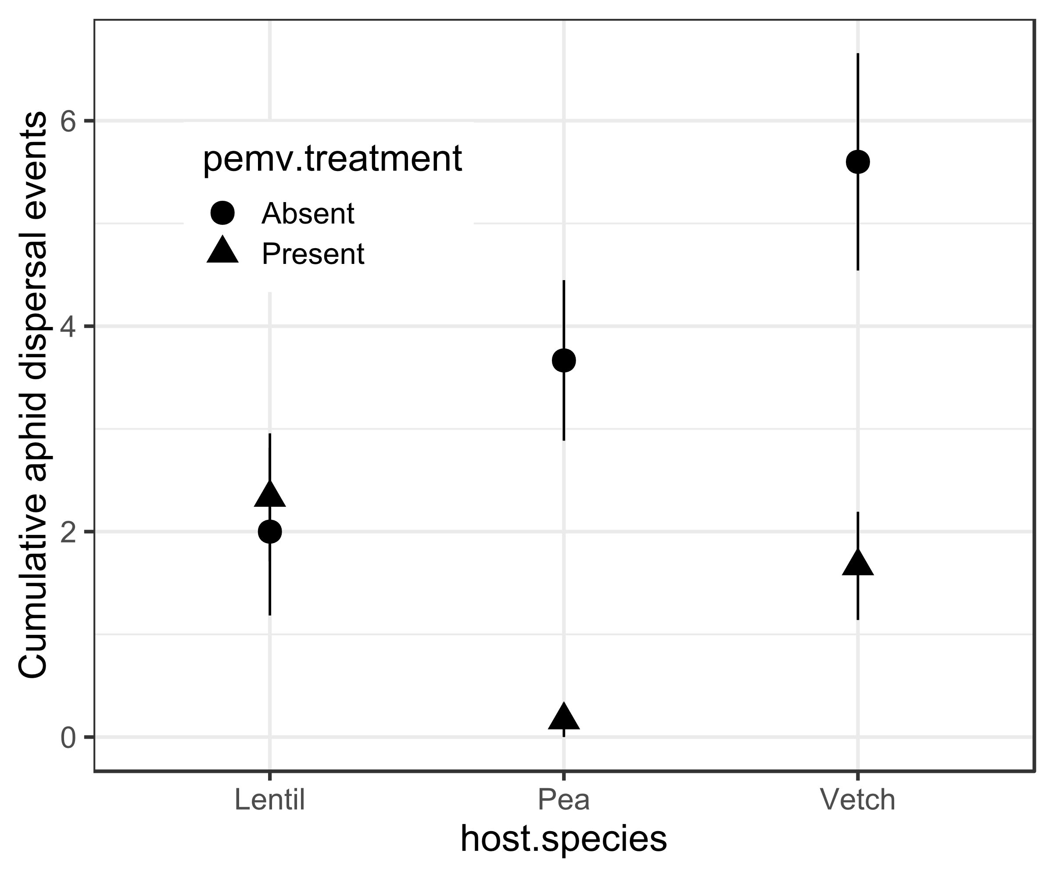

Tables.

Add sequential tables following order of figures for GLMM (all Poisson fit)